

**A 12**

**Sreenidhi Institute of Science & Technology**

**(An Autonomous Institution)**

**Code No: 121ME03**

**B. TECH. I – Year II – Semester Examinations, July, 2014 (Regular)**

**ENGINEERING MECHANICS (ME)**

**Time: 3 Hours Max. Marks: 70**

**Note: No additional answer sheets will be provided.**

**Part-A**

Max.Marks:20

Answer all QUESTIONS.

1. When will the product of inertia of a lamina will be zero.
2. State the laws of dry friction.
3. A body moves along a straight line so that its displacement from a fixed point on the line is given by S= 4t2 + 5 t. find the velocity and acceleration at the end of 3 seconds.
4. A particle of mass 10Kg falls vertically from a height of 100m from the ground. What is the change in potential energy when it has reached a height of 50 m.
5. State theorems of pappus.
6. State and explain parallel axis theorem for area.
7. Distinguish between a frame and a machine with example.
8. Draw the free – body diagram of the uniform beam shown in the fig. below. The beam has a mass of 100kg.

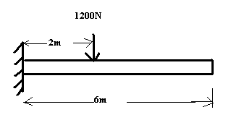

1. Write down the expression for centre of gravity of a right circular cylinder about its base.
2. State the polygon law of forces.

Part – B

Max. Marks: 50

ANSWER ANY FIVE QUESTIONS. EACH QUESTION CARRIES 10 MARKS.

1. a. Determine the resultant of concurrent forces shown in the figure below.

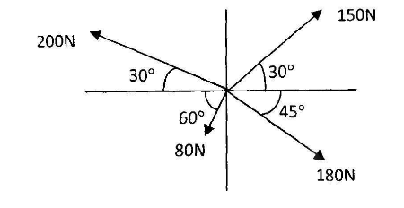

b.The figure shows a 10 kg lamp supported by two cables AB and AC. Find the tension in each cable.

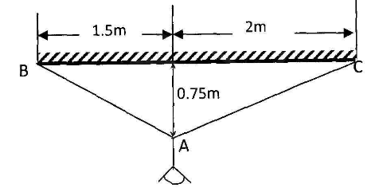

2. Two identical rollers, each of weight 500N, are supported by an inclined plane making an angle of 300 to the horizontal and a vertical wall as shown in the figure.

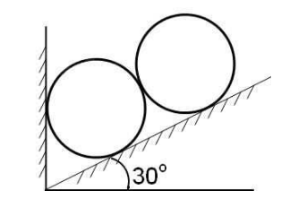

i) Sketch the free body diagrams of the two rollers.

ii) Assuming smooth surfaces, find the reactions at the support points.

3. a. Derive from the first principles, the second moments of area Ix x and Iy y for the rectangular area when the axes are as shown below.

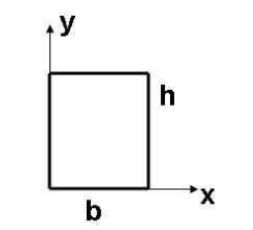

b. Determine the second moment of the shaded area under the curve y = kxn,

as shown in Fig., with respect to specified X - and Y – axis.

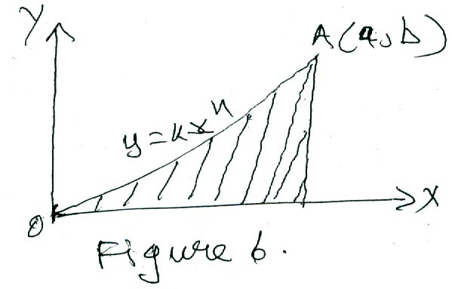

4. a. locate the centroid of the area shown in the figure below. The dimensions are in mm.

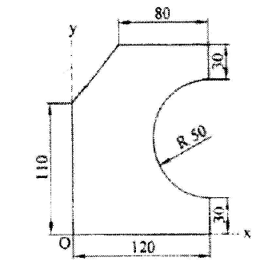

b.Determine the centroid of the area between parabola x2 = ay and straight

line y = x as shown in Figure.

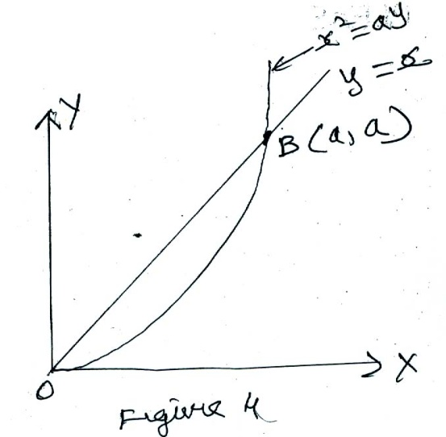

5. a. A ladder of weight 1000 N and length 4m rests as shown in the figure.

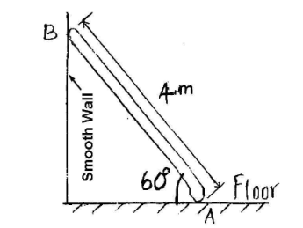

If a 750 N weight is applied at a distance of 3m from the top of ladder, it is at the point of sliding. Determine the coefficient of friction between ladder and the floor.

b. A rope is wrapped three times around a rod as shown in the figure.

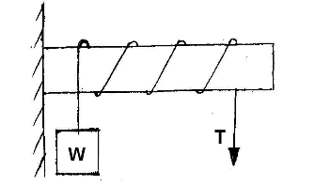

Determine the force required on the free end of the rope, to support a load of W = 20 KN. Assume µ= 0.30.

6. Determine the forces in the members of the truss BE and CE as shown in the below figure.

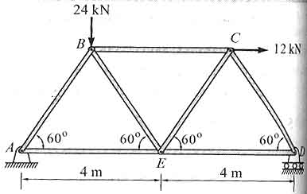

7. a. State the laws of kinetic friction.

b. Two blocks of weight 500N and 1K N connected by rod are kept on an inclined plane as shown in the fig. the rod is parallel to the plane. The coefficient of friction between 500N block and plane is 0.4 and that between 1kN block and plane is 0.3. find the inclination of the plane with the horizontal and the tension in the rod when motion down the plane is just about to start.

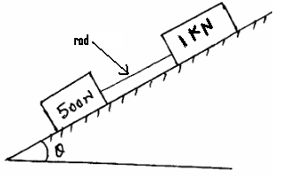

8. Derive the mass moment of inertia of a solid right circular cone of base radius R and height H with respect to its geometric axis of rotation.

-- 00 -- 00 --